**LT6.1 Graphing Cubic Functions**

**Problems 1-6: Make a graph and make a table below the graph. Find the x-intercepts.**

**1. $y=x^{3}$** **2. $y=x^{3}+2$** **3.**

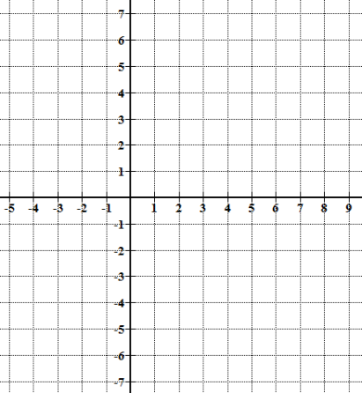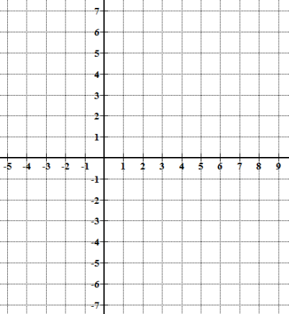

x-intercepts: ___________ x-intercepts: _____________ x-intercepts:__________

**4.** Identify the following significant features of the graph of a cubic function.

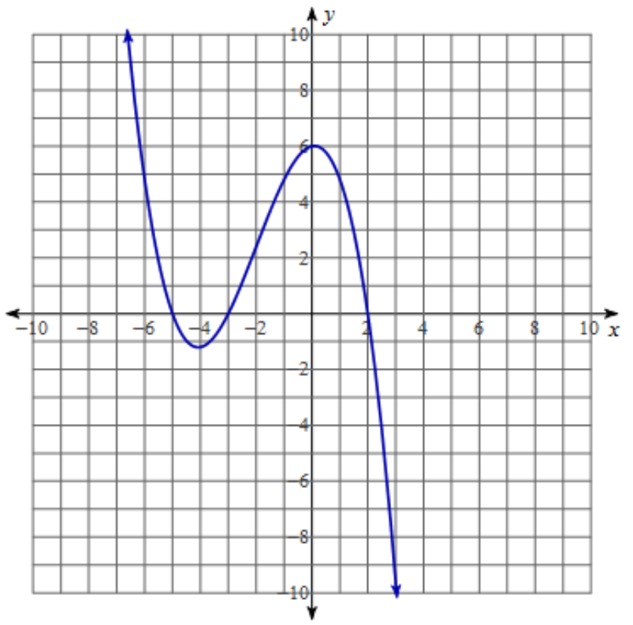

Domain _________________

Range _________________

Relative Maximum (estimate) _________________

Relative Minimum (estimate) _________________

Increasing Interval(s) (estimate) _________________

Decreasing Interval(s) (estimate) _________________

x-intercept _________________

y-intercept _________________

End Behavior: _________________

**LT 6.2 Operations with Polynomials**

**Problems 5-7: Simplify the Expression.**

**5. $x^{3}∙{\left(x^{2}\right)}^{3}$** **6. ${\left(\frac{6a^{3}b^{5}}{2a^{2}b^{4}}\right)}^{3}$**

**7. ${\left({4m}^{0}n\right)}^{2}$**

**Problems 8-13: Add, Subtract, Multiply, or Divide the Polynomials**

**8**. $\left({2x}^{3}+6x^{2}-x+6\right)+(-4x^{3}+6x^{2}+x+18)$

**9. $\left(x^{4}-3x^{3}+x-7\right)-(-3x^{4}+2x^{2}-x+15)$**

**10. $(x+1)(3x+7)(x-7)$**  **11. $({4x}^{3}+x^{2}+8x)(x^{2}-8x+13)$**

**12**. $\frac{2x^{3} + {3x}^{2} - 29x - 60}{x^{2}-4}$**13. $\frac{x^{4} + 7x^{3} - {5x}^{2} - 4x + 8}{x+3}$**

**LT 6.3 Solving for Cubic Functions and Polynomial Equations**

**Problems 14-19: Solve by graphing in a graphing calculator. Round to the nearest tenth.**

**14. $x^{3}-8x^{2}+7x+9=0$** **15. $6x^{3}+18x^{2}-2x+3=7$**

**16. $-2x^{3}+2x+5=0$** **17. $4x^{3}+4x^{2}-39x+36=0$**

**Problems 5-6: Find all zeros. Divide the function by the given factor, then solve for x.**

**18. $x^{3}+7x^{2}-6x-72=0, x+6$** **19. $2x^{3}+13x^{2}-70x-225=0, 2x+5$**

**20.** A construction company is building new homes. The median cost of building these homes can be modeled by the function $\left(x\right)=0.6199x^{4}-55.9808x^{3}+1518.304x^{2}-8252.987x+301070.846$, where x is the number of years since 1970. In what year was their cost at $120,000?